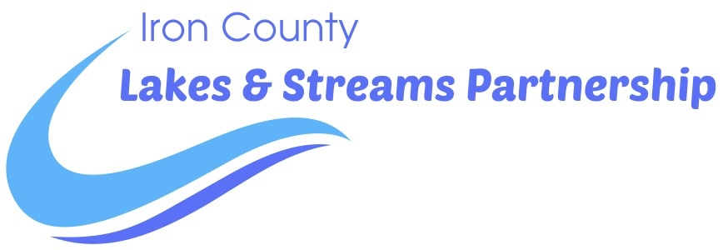

**Application for Funding**

The Iron County Lakes and Streams Partnership (LSP) is dedicated to preserving, maintaining, and enhancing the water resources of Iron County. Specifically, LSP addresses the prevention, reduction, and elimination of invasive aquatic species through awareness, education, and broadly supported and coordinated projects that utilize technology and stakeholder cooperation.

Limited grant funds are available each year and are awarded on a first-come, first-served basis. Preference is given to first-time applicants, engaged lake associations, and applications with committed matching funds. Provide the following information in your proposal. Email the completed application to: iclakesandstreamspartnership@gmail.com.

**Project Overview:**

**Organization:**

**Project Title:**

**Contact Information including address, phone, and email:**

**Summary of Project (one sentence):**

**Funding Requested:** $

**Project Description:**

* **Geographic Area: Describe the body of water for the project.**
* **Need: What is the current situation on your body of water, what has been done to date, and why do you need funding?**
* **Objective(s): What do you want to accomplish and how will it be measured?**
* **How the requested funds will be utilized:**
* **Time Line:**

**Budget: Provide a detailed budget including income and expenditures. Include matching funds.**

**Lake Map: Attach a lake map showing the location and density of targeted invasive species. (pre-management survey)**

**Additional Information:** (optional)

I attest that our organization’s board has approved this request and that a final project report will be provided to LSP upon project completion.

_______________________________________________ ______________________________

Name of Person Completing Application Date